Technical Design Report 2017

Zero Degree Calorimeter

V.P.Balandin, O.P.Gavrishchuk, V.I.Kireev, E.A.Ladygin, V.P.Ladygin, N.A.Kuzmin, Yu.P.Petukhov, S.Ya.Sychkov, A.I.Yukaev
June 2017
Detector concept

The study of the dense baryonic matter at Nuclotron (BM@N project) [1]is proposed as a first stage in the heavy-ion program at NICA [2]. The major direction in the research program of BM@N project is the production of strange matter in heavy-ion collisions at beam energies between 2 and 6 A·GeV [3] .
The other topics of the experimental program can be related with the study of in-medium effects for strange particles decaying in hadronic modes [4], hard probes and correlations [5], soft photons and neutral mesons [6], polarization effects [7] etc.
For these purposes an experimental setup will be installed at the 6V beam line in the fixed-target hall of the Nuclotron. The first results with the relativistic deuteron [8] and carbon [9] beams demonstrated the feasibility of these studies with light nuclei. An important direction of the relativistic heavy-ion collisions studies is the measurements of different observables as a function of the centrality parameter.
The concept of centrality is based on the use of the impact parameter value which possible to define as a distance between the centers of the colliding nuclei in the plane, perpendicular to the beam direction. Since the impact parameter is a non-measurable value, it is possible to use such
characteristic of the collision, as the part of a total energy which is carried away by the spectators: protons, neutrons and nuclear fragments. Most of spectators has a small transverse momentum and is emitted in a narrow cone near the primary beam direction. To measure the spectators energy the calorimeter at zero angle, so-called Zero Degree Calorimeter (ZDC), is usually used. Another purpose of ZDC is the central events selection at the trigger level during data taking.
The schematic view of the transverse cross section of ZDC for BM@N experiment is presented in Fig.1. The HCAL module [11] consists of 80 scintillator/lead layers with the sampling structure of 1/2. This sampling is optimal to obtain the e/p ratios close to 1 and the good energy resolution for all particles in the energy range of 2÷100 GeV with σE/E ~50%/(E[GeV ])^{1/2}. The results of the experiment at Nuclotron with the use of 6Li beam shown the similar energy resolution for nucleons [12]. However, optimization of the module design for Nuclotron energies is required.

ZDC setup

According to CDR 2014 [13] ZDC setup consist from 104 hadron calorimeter modules: 68 and 36 modules with the cross section 15x15 cm2 and 7.5x5.7 cm2 correspondently as shown in Fig.1.a,b.

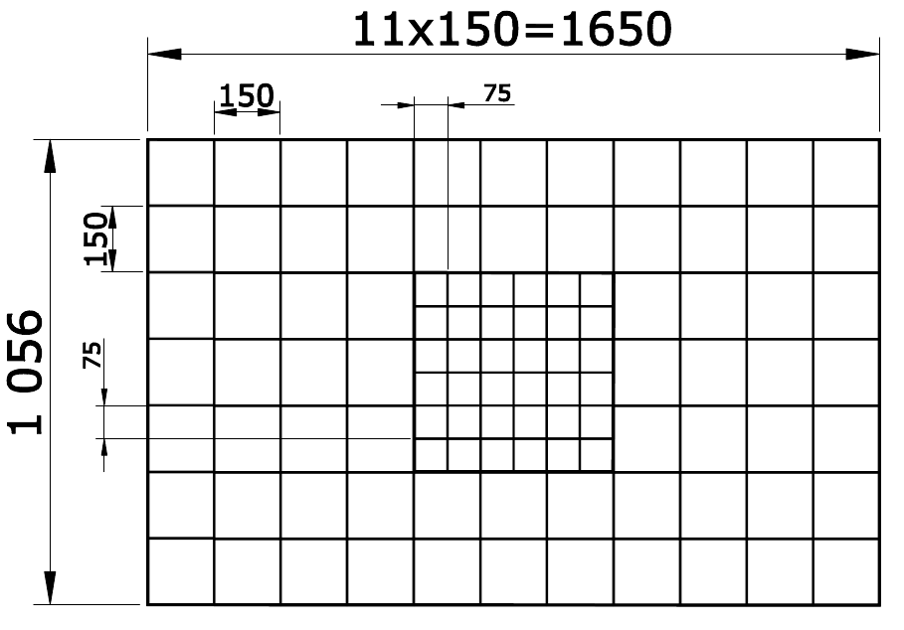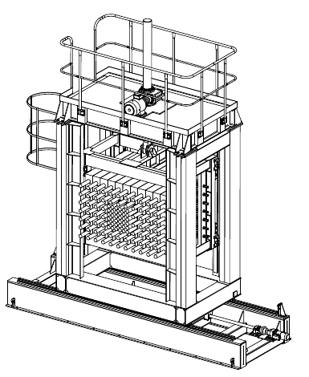
Fig.1,a. ZDC layout: central part consist of 36 modules with sizes 7.5×7.5 cm², peripheral part contains 68 modules of 15×15 cm²

Fig.1,b. ZDC setup inside of mowing platform. Schematic view of moving platform to be designed presented here.

Fig.1.a,b. ZDC setup : central part consist of 36 modules with sizes 7.5×7.5 cm², peripheral part contains 68 modules of 15×15 cm².

Small granularity in ZDC center allows one to operate with the nuclear beam intensities up to 1 MHz, which is sufficient for the first stage of the experiment and improve the space calorimeter resolution [14] up to 7 mm.
ZDC would be located in special moving platform to be manufactured for this purpose. The drawing of platform and general view of ZDC inside is shown in Fig.1,b. This platform design and platform production were performed in Novo Kramatorsk, Ukraine in 2014.

Module design

ZDC module schematic view is shown in Fig.2,a. The active module components are the PMT with voltage divider, scintillation plates, lead absorber, light guide with wave length shifter (WLS) placed in the light protective box which is as well module housing. Photos of the module is shown in Fig.2,b.

Fig.2,a. ZDC module design. 1,2 - 64 scintillator/lead layers, 3 -WLS, 4 - iron housing, 5 – PM (FEU-84) tube, 7 - PM high voltage base , 6 - mu-metal screen, 8 – fiber with an optical connector for LED light.

ZDC Setup 2015.
Beam test – February-March 2015 – Carbon nucleus.

Firs results of the BM&N experiment are described in report [16].
ZDC beam setup for February-March 2015 consist from 33 cels of 15x15 cm² and 36 cells of 7.5x7.5 cm². Central part from 52 cells link to radout system basid on ADC-64 [17,18] . ADC-64 mapping is presented in [18] . ZDC mapping is shown in Fig.9.a
Data taking for ZDC calibration was performed in Carbon beam with kinetic energy 3.5 GeV/N. The Runs description is shown in Fig.9.b. The calibration points are corresponded to central part big cell position.
Carbon beam was detected by data analysis of one scintillation counter with size 5x5 cm² and thick 5 mm , installed in front ZDC. The distribution of amplitude dE/dx from this counter were used to obtain certain nuclei types (Fig.10).
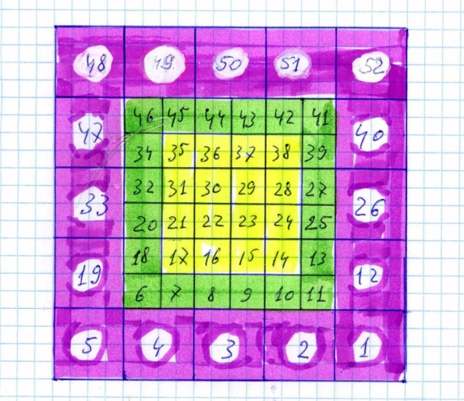
Fig.9.a. The mapping for 52 cells. Thre ZDC grops are painted. Colorized cells it is layers for summation. This cells were joint as analogical summ.

dE/dx technology allow detect nuclei in ZDC with certain charge. Calibration statistic was taken about 2*10⁴ triggers per point. In Fig 9.b shown number runs where beam position correspondent calibration points. For modules 12,1,2,3,4,5,19,32 and 47,48,49,50 all statistic were joint to single Run.

Fig.10. dE/dx distribution from scintillation counter installed in front ZDC.

ZDC calibration procedure in Carbon beam

Calibration procedure is based on minimization of the functional χ² by Minuit [26] :

χ² = 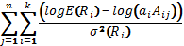
or

χ² = 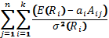

where index j for events, index i for cells (ZDC modules), E(R_{i}) is energy deposited in i-th cell with distance to shower axis R_{i} , a_{i} is i-th cell calibration coefficient, A_{ij} is i-th cell amplitude in j-th event, σ(R_{i}) is energy deposited error estimation.

Fig.13. Shower profiles for ZDC ceells sizes of 15 cm and 7.5 cm correspondently

Calibration algorithm require the coordinates of impact point in ZDC for tested particles. For this should be used trek parameters from general tracking system. In our case we can’t use a tracking data from experiment. The coordinates of impact point in ZDC were calculated using ZDC matrich. In this way the calibration cannot be good satisfactory.
The shower profile [22], as energy deposited versus distance from the shower axis to the center of the cell with size h :

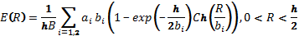

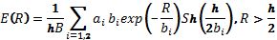

Parameters are:

a2 = 0.105 - 0.014 ln(E) ;
b1 = 1.400 - 0.120 ln(E) ;
b2 = 6.0 – 0.26 ln(E) ;
a1 = 1 - a2;

Total ZDC energy determined as sum over all 52 cells of ADC codes multiple on corresponding coefficients. Total energy from ZDC for 12C and 6Li nuclei with kinetic energy 3.5 GeV/N is shown in fig.11 take in account the calibration coefficients.

Fig.11. Total ZDC energy for Carbon beam with energy 3.5 GeV/N impact in ZDC center.
Right – ¹²Carbon , left ⁶Li nuclei, correspondently.

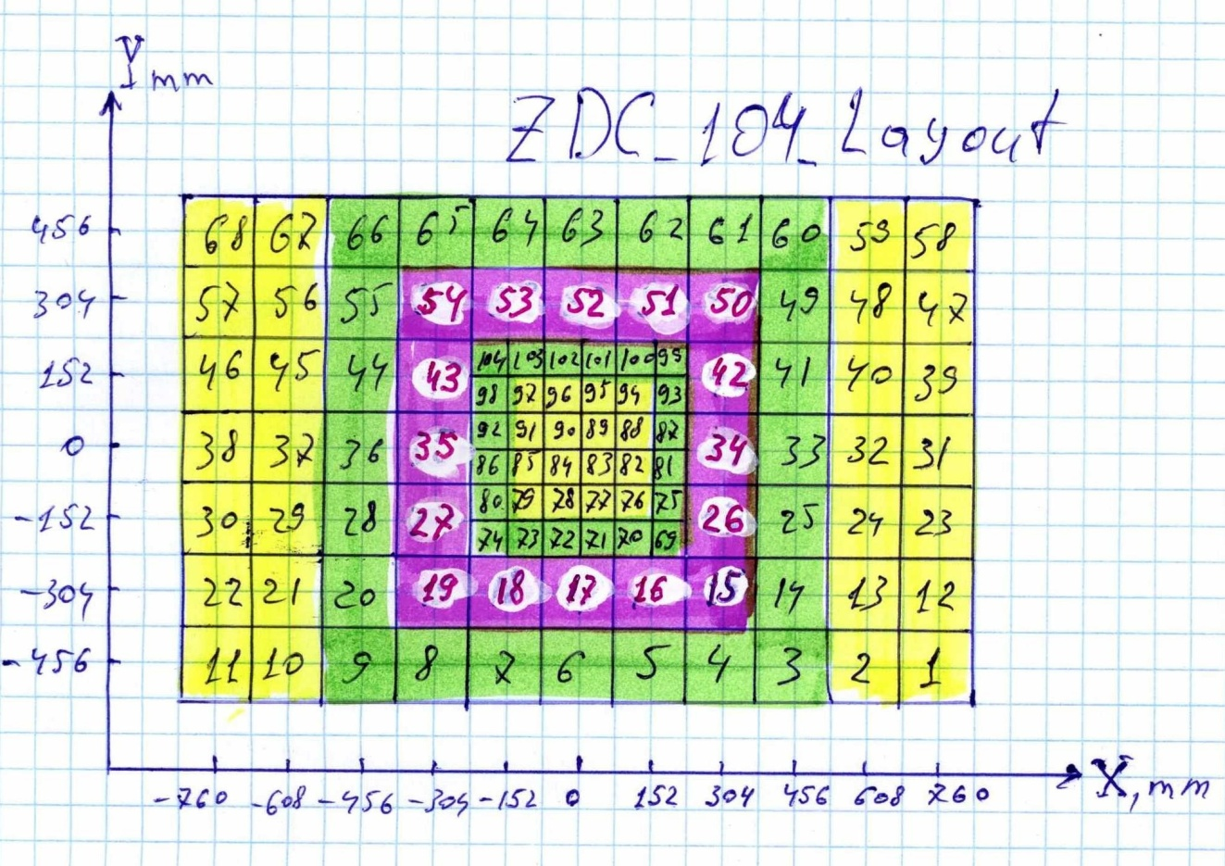

Fig.12. The mapping for 104 cells. Colorized cells it is five layers for summation.

ZDC Setup 2016.
Beam test – December 2016 – Carbon nucleus.

ZDC layout for 104 cells is shown in fig.12. Colorized cells shown ZDC layers. All modules of the layers are joint as total sum. The summation boards were borrowed with pleasure in Protvino group from Y.Mikhailov.

ZDC setup was completely assembled in end of 2015 as shown in fig.13.

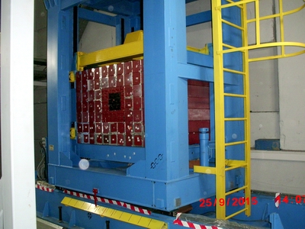

Fig.13. ZDC setup from 104 modules completely assembled.

Cosmic test for all 104 modules was performed before nuclear beam test and were obtaned all coefficients for equlizing of individall ZDC channels. The hight voltage for PM were adjusted according to cosmic results.
The LED monitoring system used for calorimeter stabiliy during data taking. The blue light (480 nm) from single light diode distributed on 104 channels. Pin diode used for checking of light stability.
Hadron ZDC calorimeter was completely ready to taken data in December 2016.
ZDC consist from 104 modules:
  - 68 - with sizes 150х150 mm² ;
  - 36 - with sizes 75х75 mm² .
Calorimeter was calibrated in Deuterons beam with energy of 4 GeV/N. The table of calibration coefficients for December 2016 is updated for BMN-root. The beam profile in ZDC shown in Fig.14.
Scan (for the calorimeter response and energy resolution) was done in X range from -460 mm to +600 mm and for Y closed to zero (+17 mm) in deuterium beam without target and magnetic field 1600 A, Fig.15. The energy spectra are also shown in Fig.14.
  - σE/E - 2.9% - amplitude uniformity (response);
  - σR/R - 9.1% - energy resolution uniformity;
σE/E = 60%/ - energy resolution has a good agreement with Monte-Carlo.

Calorimeter has a good efficiency for measured the deuterium nuclei energy as well the energy of fragmented particles : neutrons and protons.

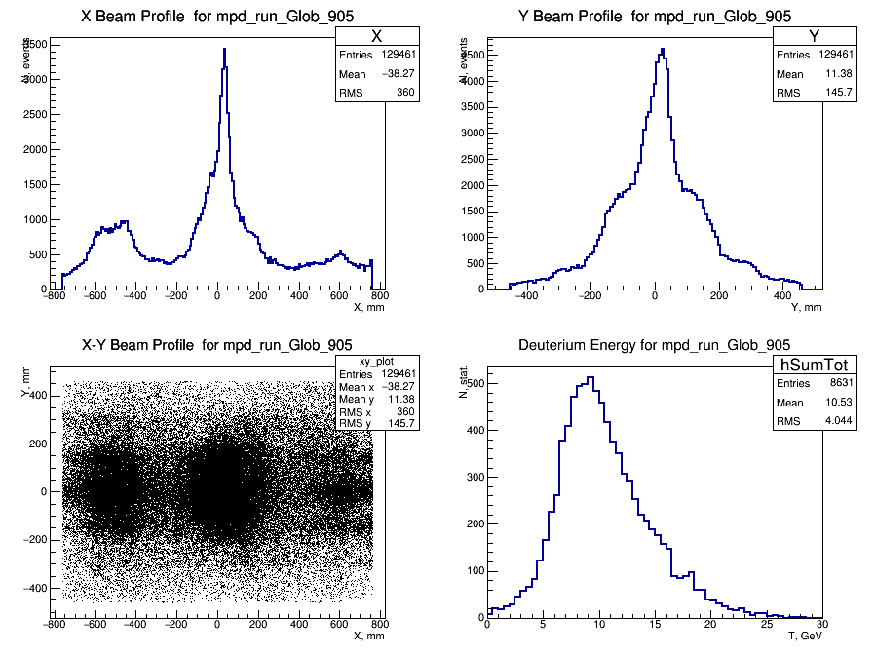

Fig.14. Deuterium beam (4 GeV/N) with polyethylene target: X-Y profiles end energy response for deuterium.

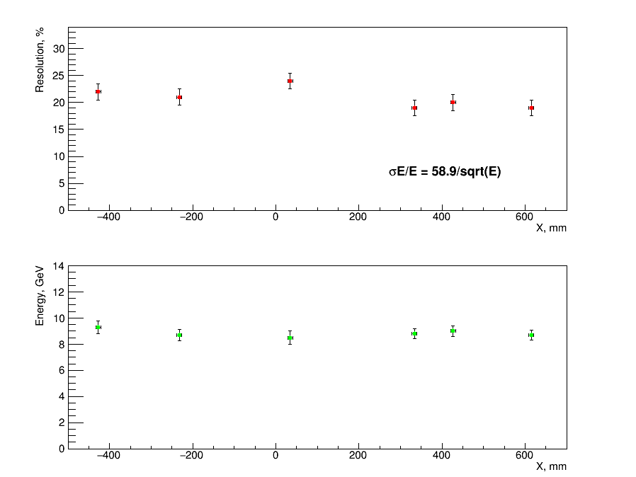

Fig.15. The uniformity scan. X-scan without target (runs 869-874) for Y=15 mm:
- Energy resolution vs X : σR/R=9.1% - resolution uniformity
- Response vs X : σE/E=2.9% - amplitude uniformity

ZDC Setup 2017.
Beam test – March 2016 – Carbon nucleys.

Zero Degree Calorimeter was calibrated in Carbon beam with energy of 4.5 GeV/N. The table of calibration coefficients for March 2017 is updated for BMN-root.
Carbon beam has interaction with Plumbum target and after deflection in magnetic field all fragments have impact in ZDC center. The energy spectra from fragmentation particle are shown in ZDC as shown in Fig.16: The Neutron are detected in ZDC as particle as not deflected in magnetic field. The Proton has maximal deflection and impact in opposite part ZDC. In ZDC center Carbon nuclei passed target without interaction.

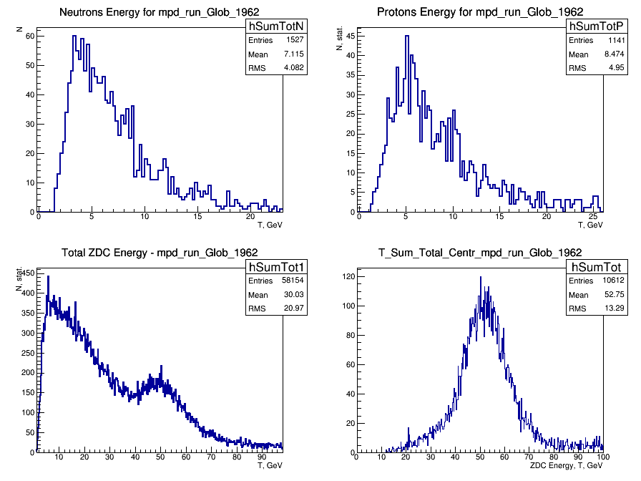
Fig.16. The Energy spectra for CarbonCu interaction: Neutrons, Protons, Total energy , Energy in central part

Calorimeter has a linear response and good efficiency for all nuclear fragments in energy range from 4 (proton) to 60 GeV (Carbon). The particles energy have strong linear correlation for particles with different charges as shown in Fig.17.

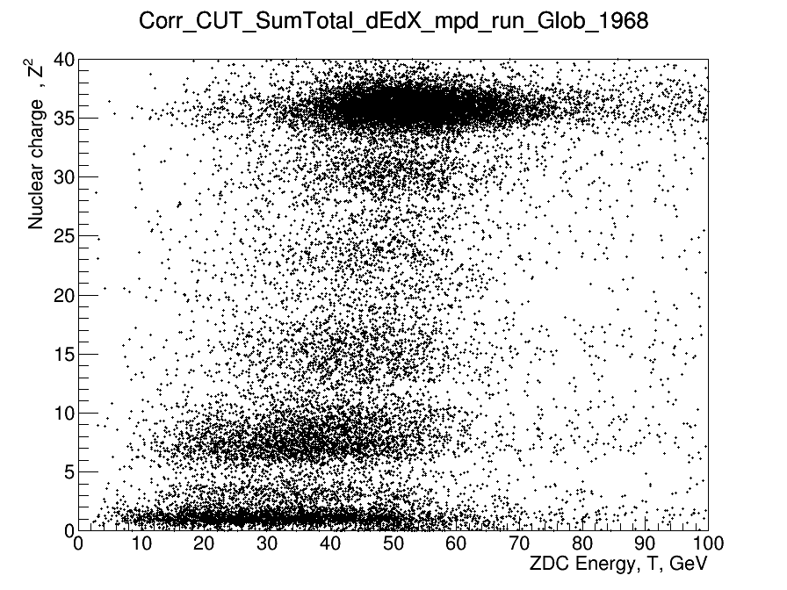
Fig.17. ZDC energy spectra versus nuclear charge. The charge merasured by dE/dX countrer 10x10 cm2 in front ZDC centre. The Carbon beam 4 Gev/N impack in Pb target.

The energy distribution and space profile in ZDC is very sensitive from atomic number of interaction target as shown shown in Fig.18.

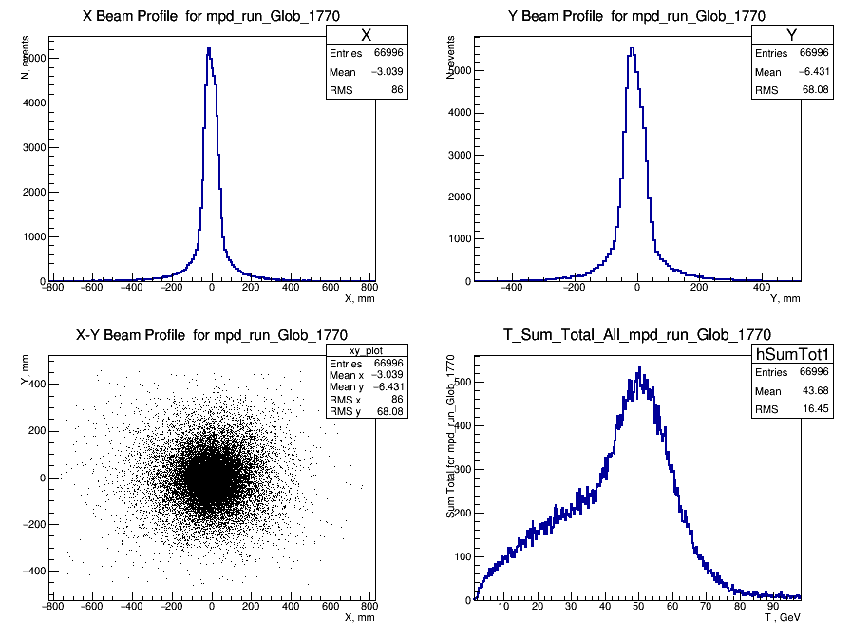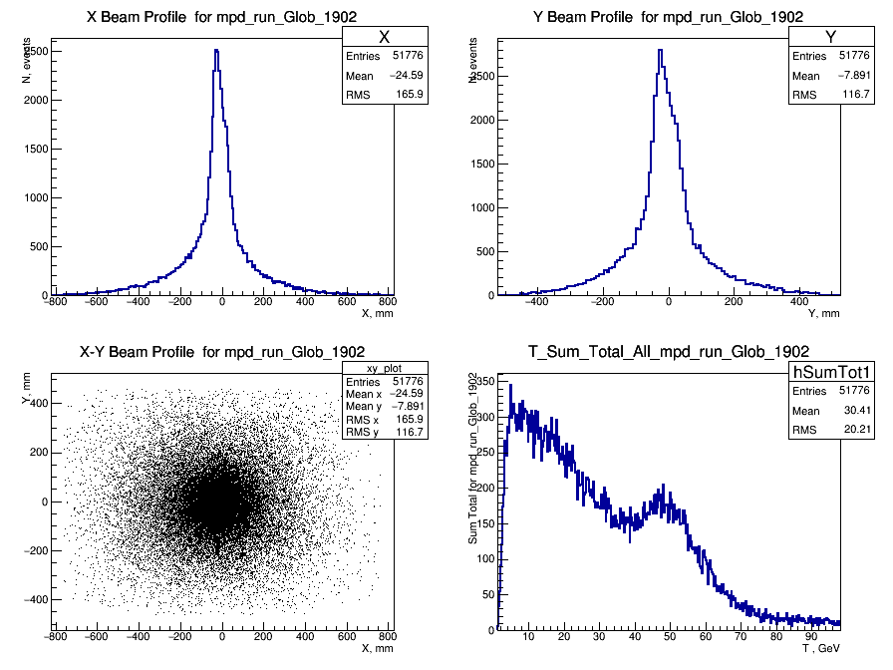

Fig.18. The beam profiles and total energy spectra: Run 1770 – without target,
Run 1902 – Pb 9.9 mm.

ZDC has divided on central (inner) and peripheral (outer) parts. The Inner energy – is sum from central 16 modules with sizes 75х75 mm2 , as shown in Fig.12 – center, yellow. The Outer energy – is sum from peripheral 64 modules with sizes 150х150 mm² and 20 modules with sizes 75х75 mm² , as shown in Fig.12 – center, green. The energy distribution in Inner and outer ZDC parts has dependency from Atomic number of interacting target, as shown in Fig.19.

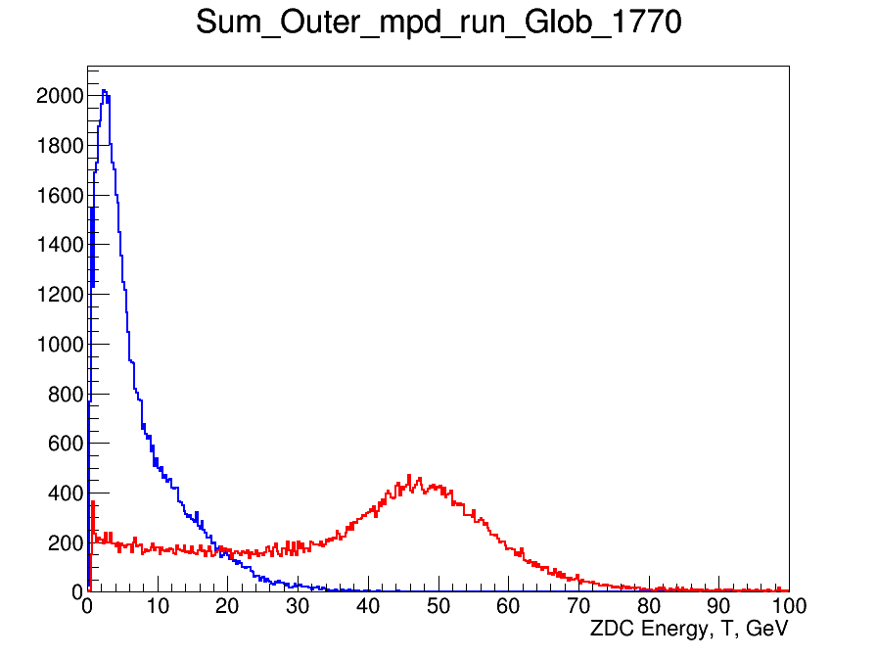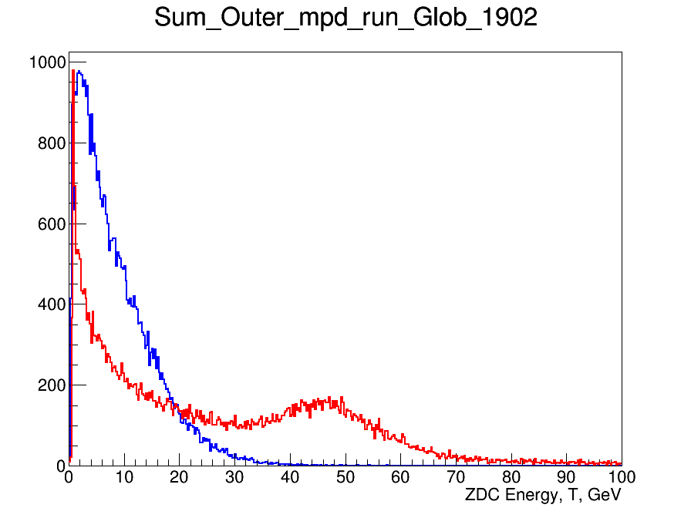

Fig.19. The Inner and Outer Energy spectra for empty (run 1770) and Pb targets
(run1902) for Carbon beam 4.5 Gev/N. Blue line – Outer , Red line – Inner
energy in calorimeter.

ZDC energy distribution in Inner and Outer part can be used for interaction centrality estimation. The Energy asymmetry calculated as ratio:

Asymmetry = (E_Inner – E_Outer)/ (E_Inner + E_Outer)

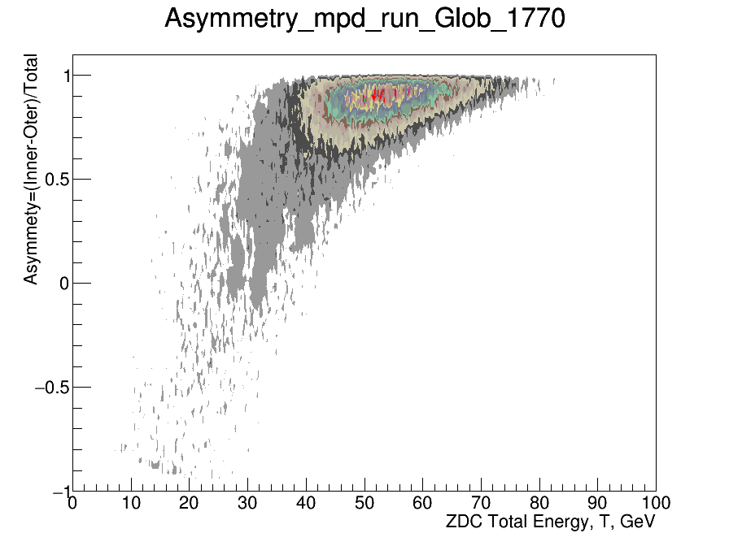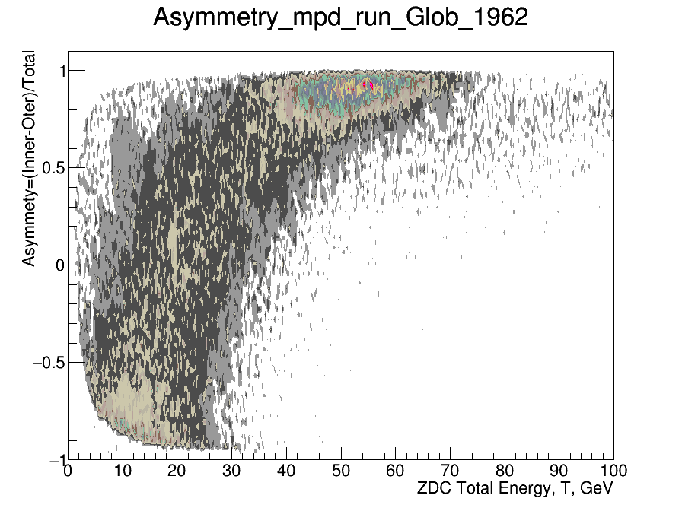
Fig.20. The Energy Asymmetry distribution for different Run conditions: Run 1770 – without target, Run 1962 - Pb target 9.9 mm thick.

Conclusions

Zero Degree Calorimeter has a linear response and good efficiency for all nuclear fragments in energy range up to 60 GeV. The ADC scale allow measurement the signals amplitudes up to 200 GeV.

The Energy resolution is in agreement with MC calculation and correspond to:
-=60%/
The amplitude uniformity vs position (response):

  - σE/E=2.9%

The energy resolution uniformity vs position:

  - σR/R=9.1%

ZDC can be useful for BM&N setup as trigger sensitive to centrality of interaction.

References
[1] Ablyazimov T. O. et al. (BM@N Collaboration) // Conceptual Design Report of BM@N. http://nica.jinr.ru/files/BM@N/BMN-CDR.pdf
[2] Kekelidze V. D., Sorin A. S. et al. (NICA Collaboration) http://nica.jinr.ru
[3] Ladygin V. P. et al. (BM@N Collaboration) // PoS Baldin-ISHEPP-XXI. 2012. P.038.
http://www.desy.de/~kapishin/nica/dac/BMN_DACreport2.pdf
http://theor.jinr.ru/~praha/2015/talks/Babkin.pdf.
[4] Bratkovskaya E. et al.// Nucl. Phys. A. 2013. V.914. P.387.
[5] Vasiliev T. A., Ladygin V. P. .Malakhov A. I. //Nucl. Phys. Proc.Suppl. B. 2011. V.219-220. P.312.
[6] Kokoulina E. et al. (SVD-2 Collaboration) // PoS ICHEP2012. 2013.P.259.
[7] Ladygin V. P. et al.// In Proc. of the XV-th Advanced Research Work-shop on High Energy Spin Physics (DSPIN-13), 8-12 October 2013,Dubna, Russia; Edited by A.V. Efremov and S.V.Goloskokov, JINR,Dubna, ISBN 978-5-9530-0315-3. 2014. P.239.
[8] Terekhin A. A. et al.// PoS Baldin-ISHEPP-XXI. 2012. P.005.
[9] Piyadin S. M. et al. // Phys.Part.Nucl.Lett. 2012. V.9. P.589.
[10] Arefiev V. A. et al.// JINR Rapid Communications. 1996. V.5[79]-96.P.15.
[11] Vlasov N. V. et al.// Instrum. Exp. Tech. 2006. V.49. P.41.
[12] Balandin V. P. et al.// JINR Preprint. R13-2008-196. 2008. Dubna. (inRussian).
[13] http://www.desy.de/~kapishin/nica/dac/TSR_All21June.pdf
[14] http://web.ihep.su/library/pubs/prep2013/ps/2013-23.pdf
ГОСУДАРСТВЕННЫЙ НАУЧНЫЙ ЦЕНТР РОССИЙСКОЙ ФЕДЕРАЦИИ
Г.И. Бритвич, В.В. Бреховских, В.К. Семенов, С.А. Холоденко Основные характеристики
полистирольных сцинтилляторов производства ИФВЭ
[15] :http://ihep.su/ihep/depart/scint.htm Scintillator production facility
[16]V Firs BM&N results:
https://indico.cern.ch/event/367368/contribution/36/attachments/730390/1002168/Hep_Tomiwa.pdf.
[17] ADC-64 description. http://afi.jinr.ru/ADC64s
https://indico.cern.ch/event/445524/contribution/62/attachments/1192836/1731840/Terletskiy_Warsaw.pdf.
[18] ADC-64 mapping. http://sneo2.ihep.su/zdc/adc64/MAPADC64amptoADC64s21_4.pdf.
[19] ZDC-mapping: http://sneo2.ihep.su/zdc/map52/zdc_52_layout.jpg.
[20] Координатное разрешение центральной части андронного сэмплинг - калориметра АК-600 : препринт / О.П. Гаврищук, Р.В. Еремеев, М.Г. Кадыков, И.Г. Косарев. - Дубна, 1991. - 7 с. : ил. - (Препринт / Объед. ин-т ядер. исслед. ; Р1-91-538). http://www.iaea.org/inis/collection/NCLCollectionStore/_Public/24/019/24019687.pdf
Minimization:
[21] Характеристики составного фотонадроннсо сэм Я лингкалориметра модульного типа: Препринт ИФВЭ 93122. Протвино, 19ЭЭ. 18 с , 11 рис., 1 табл.,.
http://www.iaea.org/inis/collection/NCLCollectionStore/_Public/26/047/26047708.pdf
Shower profile:
[22] Идентификация пионов и электронов в адронном сэмплинг - калориметре ячеистого типа : препринт / О.П. Гаврищук, Р.В. Еремеев, М.Г. Кадыков, В.К. Семенов. - Дубна, 1991. - 10 с. : ил. - (Препринт / Объед. ин-т ядер. исслед. ; Р1-91-554) - http://www.iaea.org/inis/collection/NCLCollectionStore/_Public/24/019/24019689.pdf
[23] Энергетические характеристики центральной части андронного сэмплинг - калориметра АК-600 : препринт / О.П. Гаврищук, Р.В. Еремеев, М.Г. Кадыков, И.Г. Косарев. - Дубна, 1991. - 8 с. : ил. - (Препринт / Объед. ин-т ядер. исслед. ; Р1-91-537 http://www.iaea.org/inis/collection/NCLCollectionStore/_Public/24/019/24019687.pdf
[24] http://www1.jinr.ru/Preprints/2008/196%28P13-2008-196%29.pdf
Препринт ОИЯИ Р1-91-538. Дубна, 1991 - испытания адронного калориметра на пучке ядер лития нуклотрона
[25] http://hvsys.ru/images/data/news/3_small_1368802865.pdf
[26] MIMUIT CERN Root: http://root.cern.ch/root/html/TMinuit.html
[27] Midas http://en.midasuser.com/membership/login.asp
[28] LeCroy http://www.tunl.duke.edu/documents/public/electronics/Lecroy/lecroy_2249-2259.pdf
[29] Polystyrene : PSM-115 http://www.newchemistry.ru/material.php?id=12
[30] Scintillator production. http://exwww.ihep.su/scint/index-e.htm
[31] p-Terphenil http://omlc.ogi.edu/spectra/PhotochemCAD/html/003.html
[32] POPOP http://omlc.ogi.edu/spectra/PhotochemCAD/html/077.html
[33] PMMA CO-95 http://plastinfo.ru/information/articles/357/
[34] http://www.chemicalbook.com/ChemicalProductProperty_EN_CB0328988.htm
[35] http://omlc.ogi.edu/spectra/PhotochemCAD/html/018.html
[36] http://afi.jinr.ru/ADC64s
[37] http://hvsys.ru/images/data/news/3_small_1368802865.pdf

